Simulation of a Chironex Fleckeri-Inspired Soft Robot

Justin Fortner

**Abstract** – Jellyfish have evolved over millions of years to become one of the most efficient and durable creatures on the planet. Of the thousands of different types of jellyfish, among the most fast, efficient and indestructible is the Box Jellyfish. The unique elongated bell structure of this jellyfish is the driving inspiration behind the biomimetic robot outlined within this paper. This paper will closely evaluate the movements of the Chironex Fleckeri, also known as the Box Jellyfish, as well as how those movements interact with the water around the animal. This evaluation will be translated to a mechanical design consisting of a rigid inner skeletal structure and a flexible outer skin. The performance of these pieces will be analyzed both together and separately using various robotic simulators. The goal of this paper is to prove the concept of a bio-inspired jellyfish robot and take the first steps in designing the system.

**Key Words:** - Biomimetic, bio-inspired, toroidal vortex, marine robotics, soft robotics, bio-material, passive functionality, active functionality.

**Note:**  This paper was written for the guidelines outlined by the IEEE RoboSoft Conference

1 Introduction

Jellyfish have evolved over millions of years to become one of the most well designed creatures on the planet. Thousands of different species of jellyfish occupy some of the harshest ecosystems in the world. Of these jellyfish one species is widely considered the most supreme. This species being the Chironex Fleckeri, more widely known as the Box Jellyfish. The Chironex Fleckeri has gained a reputation of being one of the most durable, efficient, and speedy of all the known jellyfish [12]. These qualities can be attributed to the shape and structure of their unique bell. The Chironex Fleckeri bell has a unique combination of a gelatinous muscular skin made up of mucopolysaccharide gel and rigid fibers made up of a protein called mammalian fibrillin [4].

The mucopolysaccharide gel adds both passive and active functionality to the overall body of the jellyfish. Actively the jellyfish can control the fibers housed within the gel. The manipulation of these fibers gives the jellyfish control over speed, direction and shape of the body. Control over these factors allows the jellyfish to maneuver through tight spaces safely as well ride ocean currents and vortexes in open water. The currents and vortexes are key in the jellyfish’s bell’s passive functionality. The bell can contort in order to maximize efficiency when riding these vortexes’ and waves. In this scenario the bell acts on a jellyfish the same way a sail acts on a sailboat.

The mammalian fibers passively adds several different functionalities. The first of which being the inner structure of the mucopolysaccharide gel. Without the fibers the bell of the jellyfish would be purely gelatinous. Much like a human would be with no bones. In addition to an internal structure, these fibers provide power and efficiency to the jellyfish pulsations. The fibers store energy as they are deformed by the outer gel layer. The energy stored within the microfibril network has been measured to be .4 newtons per square millimeter or 352 newtons per square meter [4]. This force allows for the bell to open back up after the contraction of the jellyfish bell. Thus, no energy is spent by the jellyfish during most of its swimming gait.

There have been numerous robotic attempts at recreating a jellyfish. There are both robots made from hard materials that capture the properties of the fibers and soft robots that embrace the qualities of the gel. However, none succeed in combining key trains of both portions into one system. The goal of this robot system is to incorporate the qualities of both the mucopolysaccharide gel and mammalian fibers.

2 Related Work

The structure of the jellyfish has been one of the most illusive and mysterious components of the jellyfish. Until recent technological developments the mammalian fibers remained undiscovered. Since that time much research as been done on the properties of both the mucopolysaccharide gel and mammalian fibers. Two of the most in depth discussion on the topic can be seen in the work done by [3], [4] and [16].

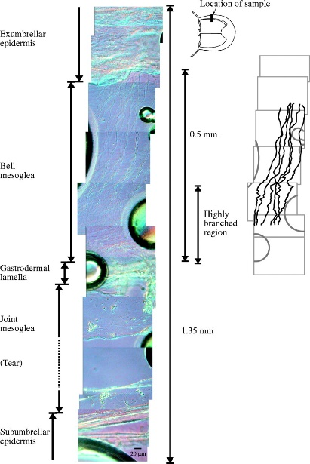

Figure 1 Cross sectional layers of a Jellyfish Mucopolysaccharide Gel [16]

Movements of jellyfish bells have been studied for decades. There have been several different gaits identified by the scientific community. The most pertinent one to this project being the resonant swimming gait. This gate is gone into detail in [4], [5], and [8]. The basic premise behind it is that as soon as the bell fully contracts it relaxes and allows for the fibers to reopen the bell. The jellyfish then quickly recloses the bell expelling a jet or water and creating a forward thrust. This process is repeated at the same rate in order to maximize efficiency of the fibers and minimize drag forces.

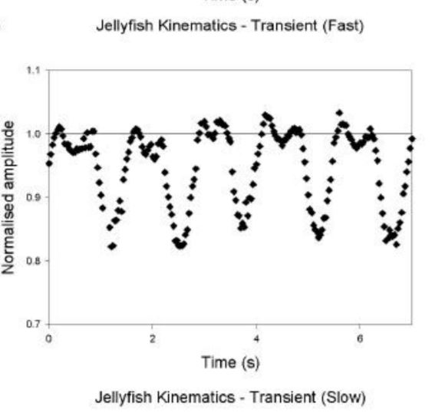

Figure 2 Jellyfish Resonant Swimming Gait

Several engineers have realized the potential the structure and kinematics of the jellyfish hold. Real world applications have been explored by [2]. While many other materials, actuator styles, shapes and bell frequencies have been explored by[1], [2], [9], [11], [13] and [14].

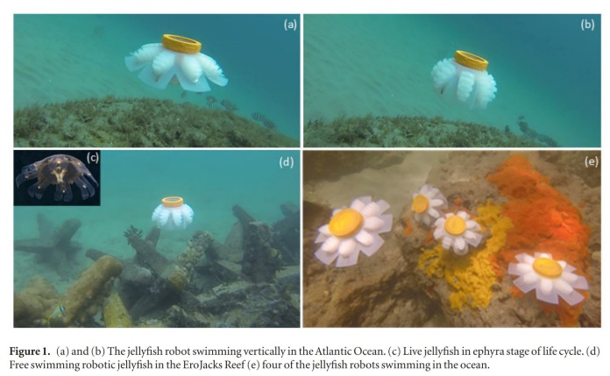

Figure 3 Bio-Inspired Jellyfish Real World Application [2]

Using all this information I have gained inspiration into the various design choices outlined in both the Jellyfish Locomotion and Design sections of this paper.

3 Design

A. Overview

In order to mimic the behavior of the jellyfish system my robot is broken down into two different portions. The first being a rigid inner skeleton responsible for both structure and movement. The second portion being a soft outer membrane responsible for flexibility and energy storage as well as vortex and current capturing. When these two portions are assembled together, they provide an opportunity to highlight the impressive qualities of both the jellyfish flexibility, durability, speed and efficiency. One important feature to note is the entire system must be neutral buoyant. This ensures the robot can operate at peak efficiency. This is accomplished through a balance of more dense metal in the skeletal structure to less dense rubber. In order to ensure the metal is not too dense portions are hollowed out and filled with air.

B. Skeleton

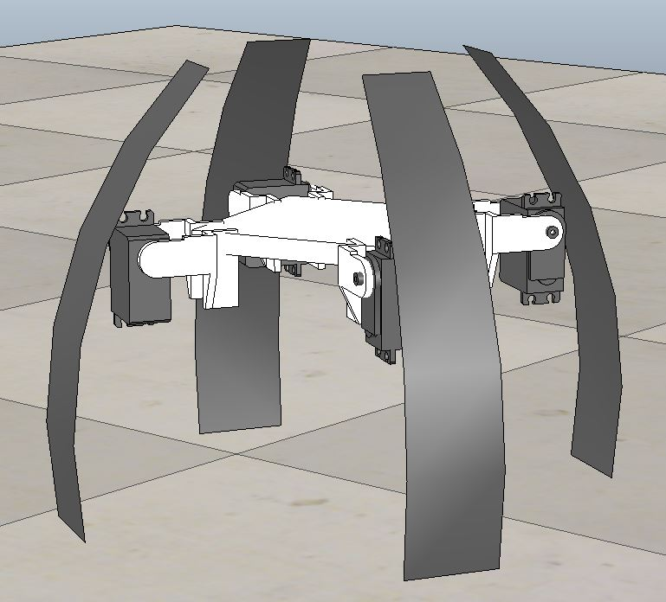

Figure 4 Jellyfish Skeleton in the Contracted Position

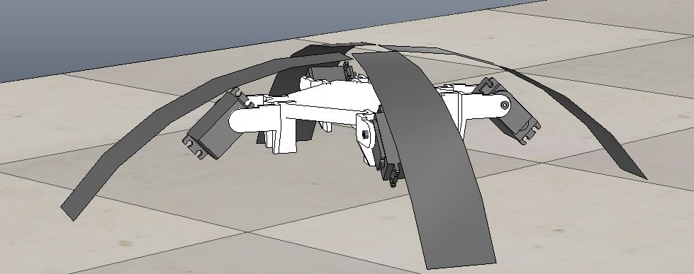

Figure 5 Jellyfish Skeleton in the Expanded Position

The general build of the skeleton consists of a base, four motors and four arms. The arms are attached in a fixed position to their own separate motor. Each motor is independently controlled along one degree of freedom. Thus, giving the jellyfish the ability to expand and contract different potions of the flexible bell separately. This distorted thrust will allow the jellyfish to pivot and twist in a variety of different orientations. Once the general shape of the jellyfish had been finalized the actual shape of the bell needed to be considered.

In order to reach the most ideal resonant swimming gate the shape of the jellyfish must follow within the finess ratio [1].

$$F=h/d$$

Where h is the height and d is the diameter of the bell. During my simulations the ideal finess ratio was found to be 2/3 as outlined in Chart 1 and 2 in the results section.

The next design aspect to consider was the range of motion and upward speed the four motors should have when in the resonant swimming gate. The most ideal design here would be the most efficient. For this calculation the Froude efficiency equation is used [1].

$${Fr}_{p}= \frac{{2V}_{m}}{V_{j}+V_{m}} × 100$$

Where $V_{m}$ is the velocity of the medusa and $V_{j}$ is the velocity of the jet. The Froude results can be seen in Tables 1 in the results section.

The skeletal structure will use the motors to actively expand the bell to its optimal position.

The final design aspect to consider is how the bell of the jellyfish will go from its open state to closed state. This is where the soft membrane comes into play.

C. Soft Membrane

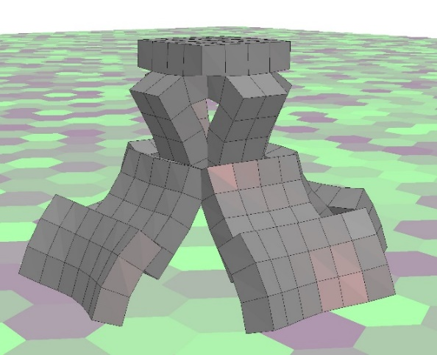

Figure 6 Jellyfish Membrane in the Contracted Position

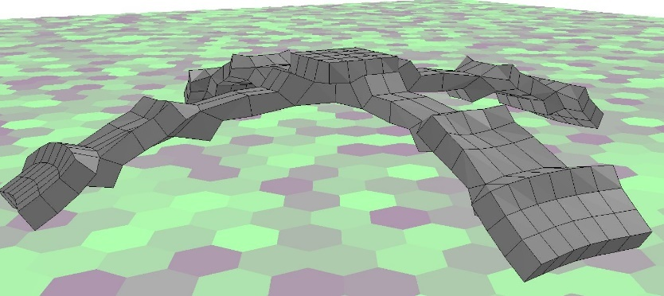

Figure 7 Jellyfish Membrane in the Expanded Position

Material selection is vital for the membrane of this robot. The material must find a balance between flexibility, strength, durability, elasticity and environmental friendliness. Research done by [2] suggests that silicone rubber is the ideal material for this application. Key properties of silicone rubber are outlined in table 1 below [17].

|  |  |
| --- | --- |
| Property | Notes |
| Flex Fatigue | Can withstand up to 5 million flexes |
| Elongation | Up to 200% before snap |
| Creep | Less then 5% after 1000 hours of use |
| Tear Strength | 9.8 kN/m |
| Thermal Resistance | -150 to 575 °F for up to 10000 hours |
| UV Resistance | Over 10 years of direct exposure |
| Water Resistance | Less then 1% change in weight, volume, tensile strength when submerged for 168 hours |
| Sea Water Resistance | Less than .5% chance when submerged for 168 hours |

*Table 1 Silicon Rubber Properties*

The design of the outer membrane will use the energy stored from the motors actively expanding to contract the bell and create a jet of thrust. Thus, propelling the jellyfish forward.

D. Assembly

The two portions of this project will be fitted together like a hand and glove. The soft membrane will stretch and slide over the hard inner skeleton. The natural tension in the soft membrane will keep it in place around the hard internal skeleton. This design choice was implemented in order to surround all hard skeletal parts with a soft membrane as well as ensure that no extra parts were needed to fasten the membrane to the skeleton.

4 Results

A. Overview

Testing and results were broken up into three parts, just like the design. The first part being the skeletal structure, the second being the soft membrane and the third being both components combined. Test and results were found for each system independently before being combined into one simulation and retested. The reason behind this is my lack of access to powerful enough programs and computers to run the type of simulation needed to analyze both rigid and soft components behavior in a fluid. I found limitations in testing both components separately. These limitations were once again brought on by the lack of computing power and program capability. However, this is the first implementation of this robot. This is not meant to be a finalized simulation. For that purpose, these tests and results are adequate. Another note, in order to be uniform all results were taken from their respective simulators and imported into a Microsoft Excel chart.

B. Skeleton

The skeleton was simulated using VREP. The following chart outline three separate Finess ratios tested within VREP. VREP stands for virtual robotic experimentation platform. The following graph was generated when three different bell shape ratios were tried in order to achieve optimal performance.

Chart 1 Distance vs Time Graph for 3 Selected Finess Ratios

The ideal ratio was found to be 2/3. The two being bell height and the three being bell diameter. Upon further inspection this ratio is in line with the average bell height (20cm) and diameter (30cm) of a boll jellyfish.

Once the ideal body ratio was found a membrane was constructed to fit over this body.

C. Soft Membrane

Results for this section are scaled down due to system limitations. The normal robot dimensions are a six inch tall bell with a 9 inch bell diameter. This simulation is a 12mm tall bell with a 18 mm bell diameter. The following simulations occurred in VoxCAD. VoxCAD allows for flexible boxes to be linked together to form a structure. Various parameters of the voxels can be configured to mimic materials. I changed all that I could in order to mimic the behavior of silicon rubber explained above. The first aspect examined in VoxCAD is the potential energy stored within the material itself.

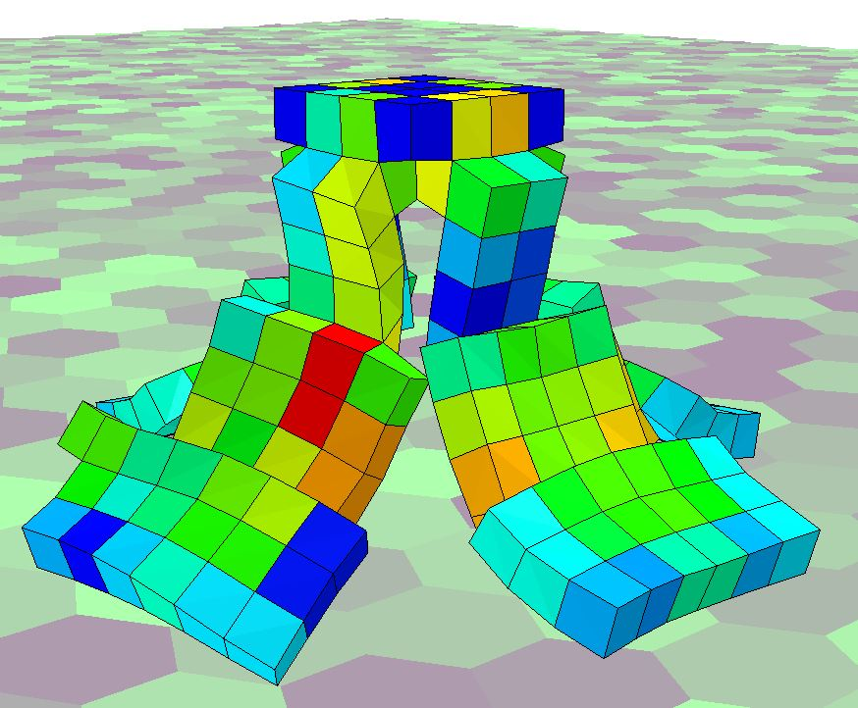

Figure 8 Soft Membrane Potential Energy Collapsed

In the contracted state all potential energy has left the material and been transferred into kinetic energy. The average potential energy in the system above is .001 mJ. This kinetic energy is what forces the skeletal structure of the bell to close. This forceful closing extrudes a jet of water behind the robot causing thrust. This driving the robot forward. After this stage the jellyfish expands back out and stores that kinetic energy generated by the skeleton as potential energy. This can be seen in the figure below.

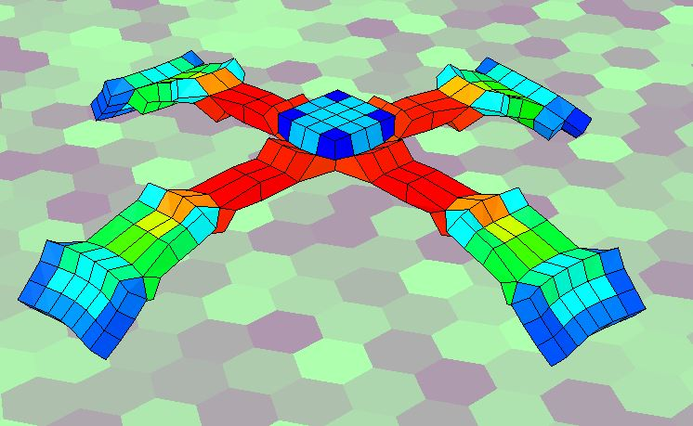

Figure 9 Soft Membrane Potential Energy Expanded

The kinetic energy within this system reaches upwards of 5 N. The areas of high energy occur in the red zone around the top of the bell. When released the material squeezes the free rotating motors of the skeletal structure and forces a 3N thrust. The thrust is outlined in the graph below.

Table 2 Bell Jet Force Membrane Only

The first .75 seconds (0-.75) represents the initial thrust of the bell. The skeleton then takes .75 seconds (.75-1.50) to reload the membrane back to the expanded position. The thrust can then be seen again over the next .75 seconds (1.5-2.25). This pattern will continue for as long as the robot is powered. This completing the resonant gait explained previously.

D. Full System

The full system data was collected after adding in the results from the VoxCAD simulation into the VREP simulation. So the two comonents were not tested together in the same simulation, but due to the computational limits discussed earlier this was the best I could do. The following graph outlines the thrust generated from the membrane collapse and the resulting vortex flowing into the expanding bell during the recoil phase.

Table 1 Comparing Range of Motion For Skeletal Arms

Table 3 Thrust Durint Both Thrust and Recoil Phase

The first .75 seconds (0-.75) represents the initial collapse of the membrane and thrust of the bell. The skeleton then takes .75 seconds (.75-1.50) to reload the membrane back to the expanded position. Vortexes created by the thrust fill the bell and cause more forward forces. The thrust can then be seen again over the next .75 seconds (1.5-2.25). This pattern will continue for as long as the robot is powered. This completing the resonant gait explained previously.

The next graph outlines the speed of the system as it travels. The same events and time is used for both the chart below as was outlined after the chart above.

Table 4 Velocity During Thrust and Recoil Phase

The final table outlines the overall efficiency of the system. The efficiency is evaluated using the Froude efficiency equation and values are only being considered at the peak efficiency of each following range of motion.

|  |  |  |  |
| --- | --- | --- | --- |
| Range of Motion (degrees) | Jet Velocity (mm/s) | Medusa Velocity (mm/s) | Froude Percentage |
| 25 | 3.7 | 1.6 | 60.37% |
| 45 | 4.5 | 2.8 | 76.7% |
| 65 | 3.4 | 1.3 | 55.3% |

As the data shows the most efficient range of motion for the arms was 45°. The 65° angle is the maximum angle the robot could go before the arms began colliding ith the body. Thus no further points could be tested above this range. Points were tested below 25° but there was a steep drop off in both efficiency and power leaving the results not worth reporting. Overall the system performs quite well according to the simulation. I do not believe for these simulations to tell the full story and a more thorough simulation needs to be performed before any definitive statements can be drawn from the result. However, these results indicate towards a successful initial design and implementation of both components separately as well as a whole.

5 Conclusion

The prototype outlined in the paper above is the first iteration in a long line of improvements to come. As access to greater computing power and software become available simulations will become more refined and exact. The soft robotics field is also rapidly advancing and developing new technologies. As these technologies advance and become more affordable and available the robot will move on from a digital simulation to real world applications. The end goal for this robot is to be able to help marine researchers collect data in order to save crumbling ecosystems. The most pressing example of this is coral reefs. 27% of all coral reefs have already been lost [17]. If action isn’t taken soon then at least an additional 30% will be destroyed over the next 30 years [17]. The only way to ensure the appropriate action is being taken is by collecting as much data as possible. This robot aims to help researchers accomplish that.

6 References

[1]J. Najem, S. Sarles, B. Akle and D. Leo, "Biomimetic jellyfish-inspired underwater vehicle actuated by ionic polymer metal composite actuators", *Smart Materials and Structures*, vol. 21, no. 9, p. 094026, 2012.

[2]J. Frame, N. Lopez, O. Curet and E. Engeberg, "Thrust force characterization of free-swimming soft robotic jellyfish", *Bioinspiration & Biomimetics*, vol. 13, no. 6, p. 064001, 2018.

[3]R. Satterlie and J. Eichinger, "Organization of the Ectodermal Nervous Structures in Jellyfish: Scyphomedusae", *The Biological Bulletin*, vol. 226, no. 1, pp. 29-40, 2014.

[4]W. Megill, *ResearchGate*, pp. 0-128, 2002.

[5]E. Demont and J. Gosline, "Mechanics of Jet Propulsion in the Hydromedusan Jellyfish, Polyorchis Pexicillatus: III. A Natural Resonating Bell; The Presence and Importance of a Resonant Phenomenon in the Locomotor Structure", *Journal of Experimental Biology*, no. 134, pp. 347-361, 1988.

[6]P. Krueger, A. Moslemi, J. Nichols, I. Bartol and W. Stewart, "Vortex Rings in Bio-Inspired and Biological Jet Propulsion", *Advances in Science and Technology*, vol. 58, pp. 237-246, 2008.

[7]S. Park, C. Chang, W. Huang and H. Sung, "Simulation of swimming oblate jellyfish with a paddling-based locomotion", *Journal of Fluid Mechanics*, vol. 748, pp. 731-755, 2014.

[8]M. McHenry, "The ontogenetic scaling of hydrodynamics and swimming performance in jellyfish (Aurelia aurita)", *Journal of Experimental Biology*, vol. 206, no. 22, pp. 4125-4137, 2003.

[9]S. Yeom and I. Oh, "A biomimetic jellyfish robot based on ionic polymer metal composite actuators", *Smart Materials and Structures*, vol. 18, no. 8, p. 085002, 2009.

[10]J. Nawroth, H. Lee, A. Feinberg, C. Ripplinger, M. McCain, A. Grosberg, J. Dabiri and K. Parker, "A tissue-engineered jellyfish with biomimetic propulsion", *Nature Biotechnology*, vol. 30, no. 8, pp. 792-797, 2012.

[11]H. Godaba, J. Li, Y. Wang and J. Zhu, "A Soft Jellyfish Robot Driven by a Dielectric Elastomer Actuator", *IEEE Robotics and Automation Letters*, vol. 1, no. 2, pp. 624-631, 2016.

[12]M. Shorten, J. Davenport, J. Seymour, M. Cross, T. Carrette, G. Woodward and T. Cross, "Kinematic analysis of swimming in Australian box jellyfish, Chiropsalmus sp. and Chironex fleckeri (Cubozoa, Cnidaria: Chirodropidae)", *Journal of Zoology*, vol. 267, no. 04, p. 371, 2005.

[13]L. Xiangbin and Y. Junzhi, "Design and Simulation of a Robotic Jelly¿sh Based on Mechanical Structure Drive and Adjustment", in *34th Chinese Control Conference*, Hangzhou, China, 2015.

[14]X. Li and J. Yu, "Development of a Novel Robotic Jellyfish Based on Mechanical Structure Drive and Barycenter Adjustment", in *IEEE Conference on Robotics and Biomimetics*, Zhuhai, China, 2015.

[15]C. Donatelli, S. Bradner, J. Matthews, E. Sanders, C. Culligan, D. Kaplan and E. Tytell, "Prototype of a Fish Inspired Swimming Silk Robot", in *8 IEEE International Conference on Soft Robotics (RoboSoft)*, Livorno, Italy, 2018.

[16]W. Megill, "The modulus of elasticity of fibrillin-containing elastic fibers in the mesoglea of the hydromedusa Polyorchis penicillatus", *Journal of Experimental Biology*, vol. 208, no. 20, pp. 3819-3834, 200

[17]*Shinetsusilicone-global.com*, 2018. [Online]. Available: https://www.shinetsusilicone-global.com/catalog/pdf/rubber_e.pdf. [Accessed: 14- Dec- 2018].

[18]"Coral Reefs", *Ocean Health Index*, 2018. [Online]. Available: http://www.oceanhealthindex.org/methodology/components/coral-reefs-area. [Accessed: 14- Dec- 2018].